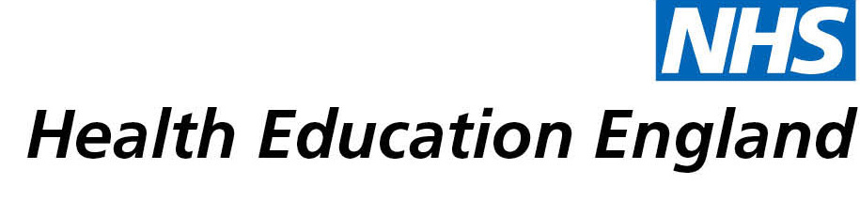

# Knowledge and Library Services Case Study

# *Berkshire Healthcare NHS Foundation Trust: Suicide by sodium nitrates/nitrites*

Date 4 January 2022

## Reason for enquiry

The suicide prevention group were creating a strategy and it had been noticed that there had been an increase of sodium nitrate related suicides locally. The search was requested to explore if this was in line with national and international trends and understand more about the subject.

## What the knowledge and library specialist did

The Librarian performed an evidence search on the use of sodium nitrates/nitrites in suicide using healthcare databases, Clinical Key and UpToDate. They also provided details of relevant Regulation 28 Reports to Prevent Future Deaths from inquests and local newspaper stories on suicides using sodium nitrates/nitrites.

# Impact of input from the library and knowledge service

The evidence search service saved the team time as it streamlined the thoughts around the use of sodium nitrites/nitrates as a suicide method. Key articles were selected and circulated to senior clinical team to consider and explore further before finalising the suicide prevention strategy.

## Immediate Impact

*“I think it's increased from the team’s awareness of the impact that sodium nitrate can have, particularly around its availability to certain groups in society, which was something we may not have zoomed in on, had we not done the literature search”*

## Probable future Impact

*“…when we're involved with patients and carers we will pick up on the signs of sodium nitrate being used and it's something that we've are looking at including on our assessment form as well.”*

## Name and Job Title:

*Colin Edwards*

Head of MH Urgent Care West

## For further information on how you can get similar support contact your local NHS library and knowledge service.

**Submission Details**

***[To be completed by Knowledge and Library Service at the point of submission]***

**Name of Organisation**

Berkshire Healthcare NHS Foundation Trust

**Knowledge and Library Service Contact Email:**

library.healthcare@berkshire.nhs.uk

**Title of Case Study**

*The use of sodium nitrate/nitrite in suicide.*

**NHS Region** *[Make bold the option which applies:]*

East of England

London

Midlands

North East and Yorkshire

North West

South East

**South West**

**Sector** *[Make bold the option which applies:]*

Acute

Acute and community

Care Trust

Clinical Commissioning Group

Commissioning Support

Community Trust

Cross-sector

Local Education and Training Board

Mental Health

Mental Health / Learning Disability

Mental Health / Social Care

Primary Care

Public Health

Shared Service / Informatics

Special HA

Other. If other, please specify **Community and Mental Health Trust**

**Group Impacted** *[Make bold the option which applies:]*

Additional Clinical Services

**Administrative and Clerical**

Allied Health Professionals

Estates and Ancillary

Healthcare Scientists

**Medicine and Dental**

Multiprofessional

**Patients, Carers and the Public**

**Nursing and Midwifery**

Scientific and Technical

Students

**Impact Types** *[Make bold any of the impact types below which apply]*

**Contributed to personal or professional development**

**Contributed to service development or delivery**

Facilitated collaborative working

Health Information for Patients, Carers and the Public

Improved the quality of patient care

Mobilising evidence and organisational knowledge

More informed decision making

Productivity and efficiency

**Reduced risk or improved safety**

Saved money or contributed to financial effectiveness

Improved health and wellbeing of staff and learners

**Consent**

I have consent from individuals referred to in this case study to share details nationally for advocacy and promotion. *[Make bold the option which applies:]*

**Yes**

No